**Biofouling Management Plan**

In compliance with:

* IMO Resolution MEPC.207 (62) “2011 Guidelines for the control and management of ship’s biofouling to minimize the transfer of invasive aquatic species”
* USA:
  + US Code of Federal Regulations 33 CFR 151.2050 - [Ballast Water Management for Control of Nonindigenous Species in Waters of the United States](https://www.ecfr.gov/cgi-bin/retrieveECFR?gp=&SID=26c002e35fcd6d672a82bed14c18e96e&mc=true&n=sp33.2.151.d&r=SUBPART&ty=HTML) Additional requirements—nonindigenous species reduction practices
  + US EPA Vessel General Permit (VGP) 2013, sections: 2.2.4, 2.2.7, 2.2.8, 2.2.20, 2.2.23, 4.1.3, 4.1.4
  + California Code of Regulations Title 2, Division 3, Chapter 1, Article 4.8. “Biofouling Management to Minimize the Transfer of Nonindigenous Species from Vessels Arriving at California Ports”
* New Zealand’s Biosecurity Act and relevant Craft Risk Management Standard (CRMS)

|  |  |
| --- | --- |
| Ship’s name | Xxx |
| Flag | Xxx |
| Port of registry | Xxx |
| Gross tonnage | Xxx |
| IMO number | Xxx |
| Length | Xxx |
| Beam | Xxx |
| Ship type | Xxx |
| Call sign | Xxx |

The following information is required to be kept with the Plan:

1. MEPC.207 (62) “2011 Guidelines for the control and management of ship’s biofouling to minimize the transfer of invasive aquatic species” (available at the IMO website at this link: [MEPC.207(62)](http://www.imo.org/blast/blastDataHelper.asp?data_id=30766&filename=207(62).pdf))
2. Copy of General Arrangement Plan Dwng No Xxx (available in ship files)
3. Copy of Docking Plan from last two out-of-water Maintenance Operations (available Xxx)
4. Copy of Anti-fouling system certificate (available in ship certificates file)
5. Copy of operating instruction for MGPS (if applicable), available Xxx

**Instructions for completion and customization of a ship specific Bio-Fouling Management Plan:**

1. Text highlighted in green colour (Xxx) is intended to be ship specific and include example or proposed entries. Review ALL such text highlighted in green and change/customize as appropriate and as ship specific.
2. Text highlighted in Blue indicates guidance from MEPC.207(62) on what to include or customize – remove it once a section is customized
3. Text highlighted in yellow indicate changes since previous revision of this Plan (document control)
4. Maintain the Annexes to this Plan to record all relevant activities
5. **Regularly review and update this Plan as necessary but as a minimum after each out-of-the-water-cleaning or before each arrival at a Californian or New Zealand Port**

Table of Contents

1. Introduction 5

2. Purpose of the plan 6

3. Definitions (refer to main documents for complete details) 6

4. Description of operating profile of the ship 10

5. Description of the ship anti-fouling (AF) systems 11

5.1 Antifouling coatings – keep up-to-date 11

5.2 Marine Growth Protection Systems (MGPS) – keep-up-to-date 13

5.3 Anti-Fouling Systems Certificates 14

6. Description of areas on the ship susceptible to biofouling 15

6.1 Table - Biofouling management action plan for this ship 15

6.2 Diagram – Location of areas particularly susceptible to biofouling 21

7. Operation and maintenance of the anti-fouling system 22

7.1 Timing of operational and maintenance activities 22

7.1.1. Periodical inspections planned 22

7.1.2 Dry-docking and maintenance procedures (reference MEPC.207(62), Section 6) 22

7.1.3 Procedures for when the ship is in maintenance facilities 23

7.2 In-water cleaning and maintenance procedures between dry-docking events (reference MEPC.207(62), Section 7) 24

7.2.1 In-water inspection 24

7.2.2 In-water cleaning and maintenance 25

7.3 Operation of onboard treatment processes (MGPS) 27

8. Safety procedures for the ship and the crew 28

Table - Risks and precautions concerning the anti-fouling system(s) 28

9. Disposal of biological waste 29

10. Recording requirements 29

11. Crew training and familiarisation 30

11.1 Training Record for Biofouling Management Plan 30

Annex 1 – Local /Regional Regulations 31

1. United States 31

1.1 Code of Federal Regulations 31

33 CFR §151.2050 Additional requirements—nonindigenous species reduction practices 31

1.2 US EPA Vessel General Permit (VGP) 2013 31

https://www3.epa.gov/npdes/pubs/vgp_permit2013.pdf 31

1.3 State of California 33

2. New Zealand 35

Annex 2 / Biofouling Record Book – biofouling management actions 41

1. Introduction 41

2. Entries in the Biofouling Record Book 41

2.1 After each Dry-Docking 42

2.2 After each Diving / under water Inspection (of the hull area, fittings, niches and voids below the waterline) 43

2.3 After each Underwater Cleaning (of the hull area, fittings, niches and voids below the waterline) 44

2.4 After the Internal Seawater Cooling Systems’ inspection, cleaning or treatment 45

2.5 Ships with a Marine Growth Protection System (MGPS) fitted 46

2.6 Periods of time ship was laid up / inactive for an extended period of time 47

2.7 Periods of time when ship operating outside its Normal Operating Profile 48

2.8 Details of Official Inspection or Review of Biofouling Risk 49

2.9 Additional Observations and general remarks 50

# Introduction

The ship’s crew must follow this Biofouling Management Plan in conjunction with the following Safety Management System procedures:

[EMM](http://srv-glas301:82/Leisure/content/parent%20category%20topics/procedures%20and%20operations/emm.htm) > 2.0 Ballast Water Management Plan > [2.6 Biofouling Management procedure](javascript:void(0);)

This Plan is specific and unique for this ship, as identified at the front page.

The Plan shall be readily available to any Port State authority for viewing on request.

Annex 2 of this plan includes a Biofouling Record Book, where this ship’s crew document activities performed for biofouling maintenance.

In the adoption of the 2004 Ballast Water Management (BWM) Convention, Member States of the IMO made a clear commitment to minimizing the transfer of invasive aquatic species by shipping. Studies have shown that biofouling can also be a significant vector for the transfer of invasive aquatic species. Biofouling on ships entering the waters of States may result in the establishment of invasive aquatic species which may pose threats to human, animal and plant life, economic and cultural activities and the aquatic environment.

While the 2001 Anti-Fouling Systems (AFS) Convention addresses anti-fouling systems on ships, its focus is on the prevention of adverse impacts from the use of anti-fouling systems and the biocides they may contain, rather than preventing the transfer of invasive aquatic species.

All ships have some degree of biofouling, even those which may have been recently cleaned or had a new application of an anti-fouling coating system. Studies have shown that the biofouling process begins within the first few hours of a ship's immersion in water. The biofouling that may be found on a ship is influenced by a range of factors, such as follows:

1. Design and construction, particularly the number, location and design of niche areas;
2. Specific operating profile, including factors such as operating speeds, ratio of time underway compared with time alongside, moored or at anchor, and where the ship is located when not is ubes (e.g., open anchorage of estuarine port);
3. Places visited and trading routes; and
4. Maintenance history, including: the type, age and condition of any anti-fouling coating system, installation and operation of anti-fouling systems and dry-docking/slipping and hull cleaning practices.

Implementing practices to control and manage biofouling can greatly assist in reducing the risk of the transfer of invasive aquatic species. Such management practices can also improve a ship's hydrodynamic performance and can be effective tools in enhancing energy efficiency and reducing air emissions from ships.

The ship’s crew must follow this Plan in conjunction with the following Safety Management System procedures:

[EMM](http://srv-glas301:82/Leisure/content/parent%20category%20topics/procedures%20and%20operations/emm.htm) > 2.0 Ballast Water Management Plan > [2.6 Biofouling Management procedure](javascript:void(0);)

# Purpose of the plan

The purpose of the Plan is to outline measures for the control and management of this ship’s biofouling to minimize the transfer of invasive aquatic species.

To minimize the transfer of invasive aquatic species, a ship must implement biofouling management practices, including the use of anti-fouling systems and other operational management practices to reduce the development of biofouling. The intent of such practices is to keep the ship's submerged surfaces, and internal seawater cooling systems, as free of biofouling as practical. A ship following this guidance and minimizing macrofouling would have a reduced potential for transferring invasive aquatic species via

biofouling.

The management measures outlined herein are intended to complement current maintenance practices carried out within the industry.

# Definitions (refer to main documents for complete details)

See also Annex 2 for local/regional requirements

|  | **IMO MEPC.207(62)** | **California**  **(Article 4.8 Section 2298.2)** | **New Zealand – Craft Risk Management Standard** |
| --- | --- | --- | --- |
| **AFS Convention** | International Convention on the Control of Harmful Anti-Fouling Systems on Ships, 2001. |  |  |
| **Algal growth** |  |  | Growth of algae that is visible to the naked eye. Algae may be either single celled filamentous forms or multicelled macroalgae (seaweed) species and includes coralline algae |
| **Anti-fouling coating** | Combination of all component coatings, surface treatments (including primer, sealer, binder, anti-corrosive and anti-fouling coatings) or other surface treatments, used to control or prevent attachment of unwanted aquatic organisms. | Any paint or other coating that prevents or deters the attachment and growth of biofouling organisms on the wetted portions of a vessel. Anti-fouling coatings may include biocidal or non-biocidal anti-fouling coatings. |  |
| **Anti-fouling system** | Coating, paint, surface treatment, surface, or device used to control or prevent attachment of unwanted organisms | Coating, paint, surface treatment, surface, or device that is used on a vessel to minimize or prevent attachment, growth or association of biofouling. |  |
| **Biocidal anti-fouling coating** |  | An anti-fouling coating containing one or more chemical substances that are toxic or act as a deterrent to the settlement of living organisms |  |
| **Biofouling** | Accumulation of aquatic organisms such as micro-organisms, plants, and animals on surfaces and structures immersed in or exposed to the aquatic environment. Biofouling can include microfouling and macrofouling (see below). | (Also referred to as hull fouling or marine growth), means the attachment or association of marine organisms to the wetted portions of a vessel or its appurtenances, including, but not limited to, sea chests, propellers, anchors and associated chains, and other niche areas. Biofouling can include microfouling and macrofouling. | The accumulation of aquatic organisms such as micro-organisms, plants and animals on surfaces and structures immersed in or exposed to the aquatic environment. |
| **Division Chief /Commission Staff** |  | Chief and Staff of the State Lands Commission |  |
| **Effective Coating lifespan** |  | The expected age of an anti-fouling coating, as determined by the manufacturer and based on the vessel-specific application scheme (e.g. coating thickness) at the time of application, at which the coating is no longer expected to satisfactorily prevent or deter biofouling. |  |
| **Extended Residency Period** |  | Remaining in one port consecutively for forty-five days or longer |  |
| **Foul-release coating** |  | A non-biocidal anti-fouling coating with surface properties that minimize the adhesion of biofouling organisms, resulting in organism detachment by vessel movement |  |
| **Goose barnacles** |  |  | Also called stalked barnacles or gooseneck barnacles, goose barnacles are ubiquitous foulers of tropical, subtropical and temperate seas, with a wide oceanic distribution that includes attachment to drift wood, floating plant debris and vessel hulls, as well as turtles and whales |
| **Hull area** |  |  | The immersed surfaces of a vessel excluding niche areas and wind/water line |
| **In-water treatment** |  | Any method or process meant to kill or inactivate, but not remove, biofouling from the wetted portions of a vessel while the vessel remains in the water |  |
| **In-water cleaning** | Physical removal of biofouling from a ship while in the water | The physical removal of biofouling from the wetted portions of a vessel while the vessel remains in the water. |  |
| **Invasive aquatic species** | Species which may pose threats to human, animal and plant life, economic and cultural activities and the aquatic environment |  |  |
| **Marine Growth Prevention System (MGPS)** | Anti-fouling system used for the prevention of biofouling accumulation in internal seawater cooling systems and sea chests and can include the use of anodes, injection systems and electrolysis | An anti-fouling system device used to reduce or prevent biofouling accumulation in internal seawater systems and sea chests. MGPS may include the use of anodes, injection systems, and electrolysis |  |
| **Macrofouling** | Large, distinct multicellular organisms visible to the human eye such as barnacles, tubeworms, or fronds of algae | Large, distinct multicellular organisms visible to the human eye such as barnacles, tubeworms, or fronds of algae |  |
| **Microfouling** | Microscopic organisms including bacteria and diatoms and the slimy substances that they produce. Biofouling comprised of only microfouling is commonly referred to as a slime layer | Microscopic organisms such as bacteria and single-celled algae and the slimy substances that they produce. Microfouling is commonly referred to as a slime layer or biofilm |  |
| **Niche areas** | Areas on a vessel that may be more susceptible to biofouling due to different hydrodynamic forces, susceptibility to coating system wear or damage, or being inadequately, or not, painted, e.g., sea chests, bow thrusters, propeller shafts, inlet gratings, dry-dock support strips, etc | Area on a vessel susceptible to biofouling due to variable hydrodynamic forces, susceptibility to coating system wear or damage, or inadequate protection by anti-fouling systems. Examples of niche areas include, but are not limited to, sea chests, bow thrusters, propeller shafts, inlet gratings, and out-of-water support strips | Areas on a vessel hull that are more susceptible to biofouling due to different hydrodynamic forces, susceptibility to coating system wear or damage, or being inadequately, or not, painted, e.g., sea chests, bow thrusters, propeller shafts, inlet gratings, dry-dock support strips, etc. Includes appendages |
| **Non-biocidal anti-fouling coating** |  | An anti-fouling coating that does not rely on one or more chemical substances intended to be toxic or act as a deterrent to organism settlement in order to achieve its anti-fouling properties. Non-biocidal anti-fouling coatings may include foul-release coatings |  |
| **Out-of-water support blocks** |  | Support blocks placed underneath the vessel while the vessel is undergoing out-of-water maintenance in a dry dock or slipway |  |
| **Out-of-water support strips** |  | Sections of a vessel's hull that rest on out-of-water support blocks while the vessel is undergoing out-of-water maintenance in a dry dock or slipway. These areas are typically not cleaned or treated with fresh anti-fouling systems, resulting in reduced anti-fouling protection |  |
| **Slime layer** |  |  | A layer of microscopic organisms, such as bacteria and diatoms, and the slimy substances that they produce. |
| **Treatment** | Process which may use a mechanical, physical, chemical or biological method to remove or render sterile, invasive or potentially invasive aquatic species fouling a ship. |  |  |
| **Wetted portion of a vessel** |  | All parts of a vessel's hull and structures that are either submerged in water when the vessel is loaded to the deepest permissible draft or associated with internal piping structures in contact with water taken onboard |  |
| **Wind and water line** |  |  | The area of the hull that is subject to alternating immersion due to a vessel’s movement or loading conditions (also known in shipping as the Boot-top) |

# Description of operating profile of the ship

This ship has the following operating profile, which has influenced the specifications of the ship's anti-fouling systems and operational practices (or anticipated trading patterns)

|  |  |
| --- | --- |
| Factor | Ship’s operating profile |
| Typical operating speeds: | Xxx e.g. give range of speeds |
| Periods underway at sea: | Xxx e.g. average number of days per year underway/ |
| Periods static - berthed, anchored , moored: | Xxx e.g. average number of days per year berthed, anchored moored |
| Typical operating areas or trading routes: | Xxx e.g. worldwide excluding or including latitudes above 60 N/S, occasionally in fresh water areas for periods of time not exceeding XX % |
| Planned duration between dry-dockings: | Xxx e.g. 30 months |

# Description of the ship anti-fouling (AF) systems

Anti-fouling systems and operational practices are the primary means of biofouling prevention and control for existing ships' submerged surfaces, including the hull and niche areas.

An anti-fouling (AF) system can be a coating system applied to exposed surfaces, biofouling resistant materials used for piping and other unpainted components, marine growth prevention systems (MGPSs) for sea chests and internal seawater cooling systems, or other innovative measures to control biofouling.

The anti-fouling system used shall comply with the AFS Convention, where necessary and any other local regulations (e.g., VGP in the USA)

## 5.1 Antifouling coatings – keep up-to-date

|  |  |  |  |  |  |  |  |  |  |
| --- | --- | --- | --- | --- | --- | --- | --- | --- | --- |
| Date applied | Where / which location or part of the ship | Manufacturer name, model name & product number* | Applied dry film thickness | Manufacturer’s expected effective lifespan (in months)** | AF coating operating conditions or profile to be effective  (as applicable)** | | | | Other specifications relevant to paint performance |
| Intended out-of- water maintenance (cleaning) or dry-docking interval | Range of vessel operating speeds | %-age of time underway at sea / %-age berthed, anchored, moored | Specified operating area / routes (coastal, deep-sea) |
| Xxx | Xxx | Xxx | Xxx | Xxx months | Xxx | Xxx | Xxx | Xxx | Xxx |
|  |  |  |  |  |  |  |  |  |  |
|  |  |  |  |  |  |  |  |  |  |
|  |  |  |  |  |  |  |  |  |  |
|  |  |  |  |  |  |  |  |  |  |
|  |  |  |  |  |  |  |  |  |  |

*\* Include the AFS “specification” or warranty document or other list as provided by the AFS supplier*

*\*\*If outside effective Lifespan – see section 7 on how biofouling will be managed*

| **Details of immersed areas where AF coating systems Not** **applied** - where (e.g., which parts /locations of the ship **not** protected) |
| --- |
| Xxx (location onboard / part of the ship) NOT covered by AF coating |
|  |
|  |
|  |
|  |
|  |

## 5.2 Marine Growth Protection Systems (MGPS) – keep-up-to-date

|  |  |  |  |  |  |
| --- | --- | --- | --- | --- | --- |
| Date installed | Where / which location or part of  the ship | Manufacturer name, model  name & product number* | Indicate where anodes or dosing outlets are installed (i.e. sea chest, strainer, or other location within seawater intake system) | Recommended doses and dosage frequency | Chemical used, if any |
| Xxx | Xxx | Xxx | Xxx | Xxx | Xxx |
|  |  |  |  |  |  |
|  |  |  |  |  |  |
|  |  |  |  |  |  |
|  |  |  |  |  |  |
|  |  |  |  |  |  |

|  |
| --- |
| Internal seawater systems NOT covered by MGPS and presence and location of box coolers |
| Xxx |
|  |
|  |
|  |

## 5.3 Anti-Fouling Systems Certificates

**This ship carries the following certificates and/or other documents of the anti-fouling system(s):**

|  |  |
| --- | --- |
| Document* | Reference / ID |
| AFS certificate or AFS statement of compliance | Xxx |
| Other documents | Xxx (if any, e.g. Craft Risk Management Plan for New Zealand) |
| Other |  |
|  |  |
|  |  |
|  |  |

**\* Include previous reports on the performance of the ship's anti-fouling systems, if applicable**

# Description of areas on the ship susceptible to biofouling

The following table gives an overview of this ship’s hull areas, niche areas and seawater cooling systems that are particularly susceptible to biofouling. The table also describes the management actions required for each area.

## 6.1 Table - Biofouling management action plan for this ship

(see examples for ship specific customization as highlighted in Green)

| Areas particularly susceptible to biofouling | Management actions required for each area (e.g., inspections, cleaning, repairs and maintenance) | Management actions to be undertaken if ship operates outside its usual operating profile | **Actions to take if excessive biofouling is observed** |
| --- | --- | --- | --- |
| **External hull surfaces:** | | | |
| - Vertical sides | Xxx e.g. Inspection on 6 monthly basis from dockside as much as possible  Inspected at each dry-docking and cleaned as found necessary | Xxx e.g. based on operating parameters frequency to be increased or decreased | Xxx e.g. In water cleaning planned as necessary |
| - Flat bottom | Xxx e.g. inspection at UW surveys | Xxx e.g. based on operating parameters frequency to be increased or decreased | e.g. In water cleaning planned as necessary |
| -Docking block positions | Xxx e.g. inspection at UW surveys;  Variation in block plan between dockings / bouncing the ship in the dock / in-water cleaning before/after docking / routine in-water cleaning] | Xxx e.g. based on operating parameters frequency to be increased or decreased | e.g. In water cleaning planned as necessary |
| - Boot-top (wind and water line) | Xxx e.g. inspection on 6 monthly basis from dockside, clean as found necessary and possible | Xxx e.g. based on operating parameters frequency to be increased or decreased | Xxx |
| - Bow dome | Xxx e.g. inspection on 6 monthly basis from dockside, clean as found necessary and possible | Xxx e.g. based on operating parameters frequency to be increased or decreased | Xxx |
| - Transom | Xxx e.g. inspection on 6 monthly basis from dockside, clean as found necessary and possible | Xxx e.g. based on operating parameters frequency to be increased or decreased | Xxx |
| -Out-of-water support strips | Xxx e.g. inspection at UW surveys | Xxx e.g. based on operating parameters frequency to be increased or decreased | e.g. In water cleaning planned as necessary |
|  |  |  |  |
| **Hull appendages and fittings:** | | | |
| - Bilge keels | (if applicable) Xxx e.g. inspection at UW surveys  Inspected at each dry-docking and cleaned as found necessary | Xxx (if applicable)  e.g. based on operating parameters frequency to be increased or decreased | Xxx e.g. In water cleaning planned as necessary |
| - A-brackets / stern tube | (if applicable) Xxx e.g. inspection at UW surveys | Xxx (if applicable)  e.g. based on operating parameters frequency to be increased or decreased | Xxx e.g. In water cleaning planned as necessary |
| - Stabilizer fins | Xxx e.g. inspection at UW surveys | Xxx (if applicable)  e.g. based on operating parameters frequency to be increased or decreased | Xxx e.g. In water cleaning planned as necessary |
| - Cathodic Protection anodes and systems | Xxx e.g. inspection at UW surveys | Xxx (if applicable)  e.g. based on operating parameters frequency to be increased or decreased | Xxx e.g. In water cleaning planned as necessary |
| -Draft and hull markings | Xxx e.g. inspection on 6 monthly basis from dockside, clean as found necessary and possible | Xxx e.g. based on operating parameters frequency to be increased or decreased | Xxx |
|  |  |  |  |
| **Steering and propulsion:** | | | |
| - Propeller | Xxx e.g. inspection at UW surveys | Xxx (if applicable)  e.g. based on operating parameters frequency to be increased or decreased | Xxx e.g. In water cleaning planned as necessary |
| - Propeller shaft incl. Y frames | Xxx e.g. inspection at UW surveys | Xxx (if applicable)  e.g. based on operating parameters frequency to be increased or decreased | Xxx e.g. In water cleaning planned as necessary |
| - Stern tube seal | Xxx e.g. inspection at UW surveys | Xxx (if applicable)  e.g. based on operating parameters frequency to be increased or decreased | Xxx e.g. In water cleaning planned as necessary |
| - Anchor chain | Xxx e.g. Anchor washers to be used during every operation | Xxx (if applicable)  e.g. based on operating parameters frequency to be increased or decreased | Xxx e.g. In water cleaning planned as necessary |
| - Chain locker | Xxx e.g. to be cleaned at dock | Xxx (if applicable)  e.g. based on operating parameters frequency to be increased or decreased | Xxx e.g. In water cleaning planned as necessary |
| - Rope guard | Xxx e.g. inspection at UW surveys | Xxx (if applicable)  e.g. based on operating parameters frequency to be increased or decreased | Xxx e.g. In water cleaning planned as necessary |
| - Rudder incl. recesses (pintle, lifting tubes etc) | Xxx e.g. inspection at UW surveys  Inspected at each dry-docking and cleaned as found necessary | Xxx (if applicable)  e.g. based on operating parameters frequency to be increased or decreased | Xxx e.g. In water cleaning planned as necessary |
| - Bow/Stern thrusters  - Propeller  - Thruster body  - Tunnel | Xxx e.g. inspection at UW surveys | Xxx (if applicable)  e.g. based on operating parameters frequency to be increased or decreased | Xxx e.g. In water cleaning planned as necessary |
| - Tunnel grates | Xxx e.g. inspection at UW surveys | Xxx (if applicable)  e.g. based on operating parameters frequency to be increased or decreased | Xxx e.g. In water cleaning planned as necessary |
| -Echo sounders and velocity probes | Xxx e.g. inspection at UW surveys | Xxx (if applicable)  e.g. based on operating parameters frequency to be increased or decreased | Xxx e.g. In water cleaning planned as necessary |
|  |  |  |  |
| **Seawater intakes and internal seawater cooling systems:** | | | |
| - Engine cooling system | Xxx  e.g. As per PMS, opened up at regular intervals to inspect growth, cleaned as found necessary. | Xxx (if applicable)  e.g. based on operating parameters frequency to be increased or decreased | Xxx |
| - Sea chests (identify number and position, box cooler presence) | (include details of each sea chest and its position and box cooler presence)  Xxx e.g. inspection at UW surveys | Xxx (if applicable)  e.g. based on operating parameters frequency to be increased or decreased | Xxx e.g. In water cleaning planned as necessary |
| - Sea chest grate (inlet gratings) | Xxx e.g. inspection at UW surveys | Xxx (if applicable)  e.g. based on operating parameters frequency to be increased or decreased | Xxx e.g. In water cleaning planned as necessary |
| - Internal pipework and heat exchanger | Xxx e.g. As per PMS, cleaned as found necessary | Xxx (if applicable)  e.g. based on operating parameters frequency to be increased or decreased | Xxx |
| - Fire-fighting system (incl. associated sea chests, grates, internal pipework, etc.) | Xxx e.g. As per PMS, cleaned as found necessary | Xxx (if applicable)  e.g. based on operating parameters frequency to be increased or decreased | Xxx |
| - Ballast uptake system | Xxx e.g. As per PMS, cleaned as found necessary. | Xxx (if applicable)  e.g. based on operating parameters frequency to be increased or decreased | Xxx |
| - (Other) Sea inlet pipes | Xxx e.g. As per PMS, cleaned as found necessary. | Xxx (if applicable)  e.g. based on operating parameters frequency to be increased or decreased | Xxx |
| - Auxiliary services system (incl. associated sea chests, grates, internal pipework, etc.) | Xxx e.g. As per PMS, cleaned as found necessary. | Xxx (if applicable)  e.g. based on operating parameters frequency to be increased or decreased | Xxx |
| -Potable water generation | Xxx e.g. As per PMS, cleaned as found necessary. | Xxx (if applicable)  e.g. based on operating parameters frequency to be increased or decreased | Xxx |
| -Ancillary systems | Xxx e.g. As per PMS, cleaned as found necessary. | Xxx (if applicable)  e.g. based on operating parameters frequency to be increased or decreased | Xxx |
| -Free flood spaces / voids | Xxx e.g. As per PMS, cleaned as found necessary. | Xxx (if applicable)  e.g. based on operating parameters frequency to be increased or decreased | Xxx |
| -Box coolers | Xxx e.g. As per PMS, cleaned as found necessary. | Xxx (if applicable)  e.g. based on operating parameters frequency to be increased or decreased | Xxx |
| -Moon pools | Xxx e.g. As per PMS, cleaned as found necessary. | Xxx (if applicable)  e.g. based on operating parameters frequency to be increased or decreased | Xxx |
|  |  |  |  |
| **Overboard discharge outlets:** | | | |
| Xxx | Xxx e.g. inspection at UW surveys | Xxx (if applicable)  e.g. based on operating parameters frequency to be increased or decreased | Xxx e.g. In water cleaning planned as necessary |
|  |  |  |  |
|  |  |  |  |
| **Areas prone to anti-fouling coating system damage** or in case of grounding grounding  (e.g., **areas of the hull damaged by fenders when alongside** , leading edges of bilge keels and propeller shaft "y" frames) | | | |
| Xxx | Xxx e.g. inspection at UW surveys, esp. in case of grounding | Xxx (if applicable)  e.g. based on operating parameters frequency to be increased or decreased | Xxx e.g. In water cleaning planned as necessary |
|  |  |  |  |
|  |  |  |  |

## 6.2 Diagram – Location of areas particularly susceptible to biofouling

*Insert a diagram that identifies the locations of those areas that are particularly susceptible to biofouling (including access points in the internal seawater cooling system) , show both sides and bottom side of the ship or use the below sketch to indicate such areas, use frame numbers to identify locations*

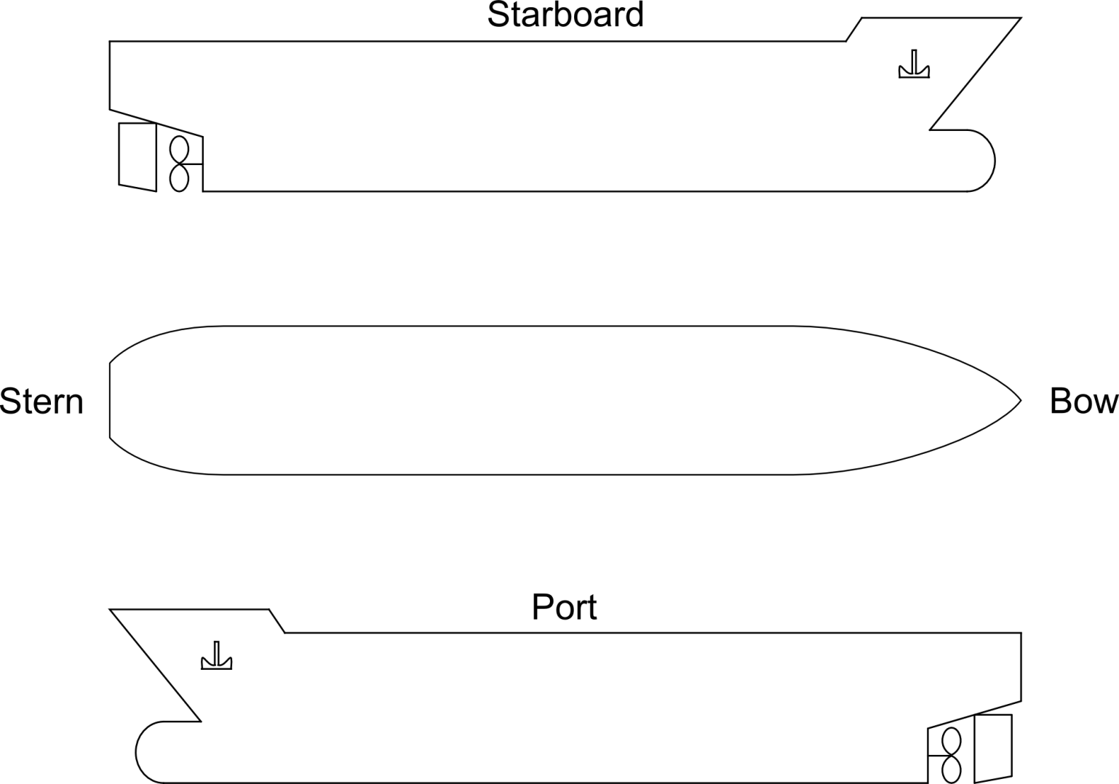

# Operation and maintenance of the anti-fouling system

*This section should be further customized (especially the parts highlighted in green) to contain a detailed description of the operation and maintenance of the anti-fouling system(s) used, including schedule(s) of activities and step-by-step operational procedures.*

*For California – if the foul-release coating is expected to be aged beyond its manufacturer’s expected lifespan – clarify so in the relevant sections below (7.1 and 7.2)*

*The Plan must show how the biofouling will be managed if the expected lifespan is exceeded of if there is no anti-fouling or foul-release coating*

## 7.1 Timing of operational and maintenance activities

For this ship, the schedule of **planned inspections, repairs, maintenance and renewal of the anti-fouling system(s)** are the following:

### 7.1.1. Periodical inspections planned

As a minimum the ship will be inspected under water every 30 months / in a dry dock

The Anti-Fouling Coating Systems shall be always renewed latest at the end of their service life

(??? or in case the coating service life is exceeded, this plan will show how biofouling will be managed???)

The following additional (if any / or applicable) ship specific AF Systems dry-docking and maintenance procedures apply:

Xxx

Xxx

Xxx

### 7.1.2 Dry-docking and maintenance procedures (reference MEPC.207(62), Section 6)

If Anti Fouling needs to be installed/re-installed, consider:

* Planned periods between drydockings
* Ship speed
* Operating profile incl. periods of inactivity
* Ship type and construction
* Expected wear, abrasion and water flow areas in specific areas of the ship
* Legal requirements for sale and use of AF Systems

If Antifouling needs to be installed/re-installed or repaired, prepare surfaces to ensure all biofouling residues, flaking paint, or other surface contamination is completely removed, particularly in niche areas, to facilitate good adhesion and durability of the anti-fouling system.

For sea chests:

* protect grates and internal surfaces with AF system
* ensure adequate adhesion and coating surface at corners, edges, blow-out pipes, holding brackets and bars of grates
* consider installing MGPS

Use best management measures for niche areas, such as:

* Dry-docking support strips - alternate their positions, so that they are painted with AF every other dry-dock or manage by other means (specialized coatings or procedures)
* Bow & stern thrusters - maintain body and areas around them and have adequate coating thickness in their housing / recesses
* Edges and weld joints - Fair and coat them around bilge keels and scoops to ensure adequate coating thickness
* Rudder hinges and stabilizer fin apertures – clean carefully and recoat them by moving rudders and fins full range during the process to ensure correct coating specification including increased wear rates in such areas
* Propellers and shafts- consider application of fouling release coatings
* Stern tube seal assemblies and the internal surfaces of rope guards – paint carefully exposed sections with AF coating appropriate to degree of water movement in such areas
* Cathodic Protection (CP) anodes –
  + consider flush-fitting mounting to the hull, inserting rubber backing pads between anodes and hull or caulking of the gaps
  + If not flush fitted – consider coating surface under anode strap with AF coating suitable for low water flow
  + If anodes are attached by bolts – consider caulking the recesses
* Pilot tubes- if such retractable used – consider coating the housing internally with AF system for static conditions
* Sea inlet pipes and overboard discharges – consider applying inside pipe openings and accessible internal areas; if the pipe material is different to the hull – consider appropriate anti-corrosive or primer coating ; take care in surface preparation for good coating adhesion and thickness

The following additional (if any / or applicable) ship specific AF Systems dry-docking and maintenance procedures apply:

Xxx

Xxx

Xxx

### 7.1.3 Procedures for when the ship is in maintenance facilities

When the ship is in a ship maintenance facility, the crew (designated Bio-Fouling Management Officer) must check and agree with the facility on the following measures, consistent with applicable national laws and regulations, as applicable:

* capturing biological material to minimize the risk of organism survival and establishment and other impacts of biological material being released into the aquatic environment
* treating and/or disposing of captured biological material in an environmentally appropriate manner
* minimize the risk of fouled ships contaminating other ships and the surrounding environment at locations where ships are awaiting cleaning and maintenance activities
* removing biofouling from all underwater surfaces of a ship when in dry-dock, including niche areas;
* lowering or extending retractable equipment such as stabilizers, thrusters, transducers and similar when a ship is in dry-dock or slipped, to permit access for the removal of biofouling from the equipment and its housing

The following additional (if any / or applicable) ship specific procedures apply:

Xxx

Xxx

Xxx

## 7.2 In-water cleaning and maintenance procedures between dry-docking events (reference MEPC.207(62), Section 7)

### 7.2.1 In-water inspection

*This section should be further customized below (especially the parts highlighted in green) to set out planned maintenance procedures (other than for on board treatment processes) that need to be completed between dry-docking events to minimize biofouling. This should include routine cleaning or other treatments. Details should be provided on the treatment/cleaning to be conducted, the specification of any equipment required, details of the areas to which each specific treatment/cleaning is to be applied, step-by-step operational procedures where relevant and any other details relevant to the processes (e.g., chemicals required for treatment, any discharge standards)*

Despite the use of effective anti-fouling systems and operational practices, undesirable amounts of biofouling may still accumulate during the intended lifetime of the anti-fouling system.

In-water inspection can be a useful and flexible means to inspect the condition of anti-fouling systems and the biofouling status of a ship.

In water inspections will be undertaken periodically (Xxx Months) as a general means of routine surveillance, augmented by specific inspections as necessary to address any situations of elevated risk.

Plan for specific occasions for an in-water inspection as appropriate, when:

* After significant change in the ship’s operating profile
* Prior to undertaking in-water cleaning to determine the degree of biofouling
* Following damage to or premature failure of the anti-fouling system

Identify all the item areas, as applicable, from 6.1 Bio-Fouling Management action and target them during inspections

Engage for In Water inspections persons suitably qualified, experienced and familiar with biofouling and associated invasive aquatic species risks and the safety risks relating to in-water surveys.

Check with relevant regulatory authorities for any accredited / approved or recommended biofouling inspection divers.

In case of limitations of visibility, dive time, or access to niche areas - consider use of Remotely Operated Vehicles (ROV) if a practical option.

The following additional (if any / or applicable) ship specific procedures apply:

Xxx

Xxx

Xxx

### 7.2.2 In-water cleaning and maintenance

**In Water Cleaning**

In-water cleaning can be an important part of biofouling management. It can also introduce different degrees of environmental risk, depending on the nature of biofouling (i.e. microfouling versus macrofouling), the amount of anti-fouling coating system residue released and the biocidal content of the anti-fouling coating system.

Relative to macrofouling, microfouling can be removed with gentler techniques that minimize

degradation of the anti-fouling coating system and/or biocide release. Microfouling removal

may enhance a ship's hull efficiency, reducing fuel consumption and greenhouse gas emissions.

It is, therefore, recommended that the ship's hull is cleaned when practical by soft methods if significant microfouling occurs.

Xxx In water cleaning will be carried out, upon review of fouling status, in port or anchorage by suitably licensed contractors and with port authority permission.

If permission is not granted, proof of same is to be attached to the Bio Fouling record book

**General guidance for In Water Cleaning**

Be aware of any regulations or requirements for the conduct of in-water cleaning, including any regulations regarding the discharge of chemicals into the marine environment and the location of sensitive areas (such as marine protected areas and ballast water exchange areas).

Where significant macrofouling growth is detected – remove or treat it (if this can be done without damaging the anti-fouling system) in accordance with such regulations.

Where available, use appropriate technology to minimize the release of both anti-fouling coating or paint debris, and viable adult, juvenile, or reproductive stages of macrofouling organisms. Dispose of the collected material in a manner which does not pose a risk to the aquatic environment.

**For immersed areas coated with:**

* Biocidal AntiFouling coatings:
  + use cleaning techniques that minimize release of biocide into the environment
    - Cleaning heavily fouled anti-fouling coating systems can not only generate biofouling debris, but prematurely depletes the anti-fouling coating system and may create a pulse of biocide that can harm the local environment and may impact on future applications by the port authority for the disposal of dredge spoil
  + Depleted anti-fouling coating systems on hulls will rapidly re-foul
    - In-water cleaning or scrubbing of hulls for the purpose of delaying dry-dockings beyond the specified service life of the coating is, therefore, not recommended
  + Xxx
* Biocide-free AntiFouling coatings:
  + require regular in-water cleaning as part of planned maintenance to maintain hull efficiency and minimize the risk of transferring invasive aquatic species.
  + use cleaning techniques which do not damage the coating and impair its function
  + Xxx

**Maintenance or repair activities:**

* take care not to impede future in-service cleaning and/or maintenance, e.g., sea chest grates do not become welded shut during repair work
* ensure that any MGPSs installed are operating effectively to prevent accumulation of biofouling
* Xxx

**Uncoated propellers and shafts**

* Consider polishing to minimize macrofouling accumulation
* Use the opportunity and the divers to assess niche areas for microfouling
* Xxx

**Internal sea water cooling systems:**

* Monitor regularly to ensure effective biofouling control
* Monitor closely and if it becomes fouled – treat accordingly (use the following chemical Xxx)
* Discharge treated water as per applicable regulations
* Xxx

## 7.3 Operation of onboard treatment processes (MGPS)

*This section should provide specific advice about Marine Growth Prevention System (MGPS) fitted, internal seawater cooling systems covered by the system and any not covered, and the associated maintenance and inspection schedule and procedures.*

*This would include information such as when each MGPS is run, for how long and any cleaning/maintenance requirements of the system once use is finished. This section should also include advice for ship operators on procedures for biofouling management if the MGPS is temporarily out of operation*

|  |  |  |  |  |  |  |
| --- | --- | --- | --- | --- | --- | --- |
| MGPS fitted | Internal seawater systems covered | Associated maintenance and inspection schedule | Maintenance and Inspection procedures | When run and for how long | Cleaning/maintenance requirements once use is finished | Biofouling management if MGPS is temporarily out of operation |
| Xxx | Xxx | Xxx | Xxx | Xxx | Xxx | Xxx |
|  |  |  |  |  |  |  |
|  |  |  |  |  |  |  |
|  |  |  |  |  |  |  |
|  |  |  |  |  |  |  |
|  |  |  |  |  |  |  |
|  |  |  |  |  |  |  |
|  |  |  |  |  |  |  |
|  |  |  |  |  |  |  |

# Safety procedures for the ship and the crew

For safety of crew – for any work including inspections on anti-fouling systems, inspections and cleaning processes follow this ship’s safety policy and procedures as detailed in the Safety Management System and any restrictions they may impose:

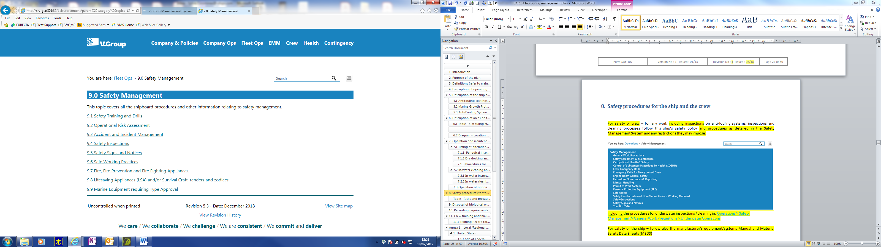

including the procedures for underwater inspections / cleaning in: [Fleet Ops](http://srv-glas301:82/Leisure/content/parent%20category%20topics/procedures%20and%20operations/fleet_ops.htm) > [9.0 Safety Management](http://srv-glas301:82/Leisure/content/parent%20category%20topics/procedures%20and%20operations/safety_management.htm) > 9.6 Safe Working Practices > [9.6.2 Permit to Work System](javascript:void(0);) > [Underwater Operations](javascript:void(0);)

For safety of the ship – follow also the manufacturer’s equipment/systems Manual and Material Safety Data Sheets (MSDS)

Follow the Permit to work system during all operations. Wear suitable PPE .

Table 8.1 below is a summary of the anti-fouling system(s) present on-board, the risks they pose and simple instructions for the precautions to be taken when working, inspecting and cleaning the anti-fouling system(s).

Safety procedures are detailed in the following documents provided by the manufacturer of the anti-fouling system(s) and related materials of chemicals:

<include reference to the section or page in the equipment maker’s Manual dealing with safety procedures and any related Material Safety Data Sheets (MSDS)>

## Table - Risks and precautions concerning the anti-fouling system(s)

List as per Equipment Manual or Material Safety Data Sheet (MSDS)

|  |  |  |  |  |  |
| --- | --- | --- | --- | --- | --- |
| Type | Applied / installed where | Manufacturer & product name | System specification | Associated risks | Precautions to be made |
| Xxx | Xxx | Xxx | Xxx | Xxx | Xxx |
|  |  |  |  |  |  |
|  |  |  |  |  |  |

# Disposal of biological waste

Disposal of biological waste generated by treatment or cleaning processes when the cleaning is conducted by, or under the direct supervision of the operator/shipowner/manager, master or crew shall be:

* properly segregated, labelled and quantity / volume estimated and recorded
* In compliance with applicable local regulations

In cases when seachest filters and/or piping is cleaned onboard - disposal will be ashore and then recorded as Garbage code -F “Operational Waste – Biofouling Residual” and regarded as special/hazardous waste.

(Alternatively, in exceptional cases only it can be disposed at more than 200nm from nearest land and this recorded accordingly)

# Recording requirements

This ship shall maintain a Record Book (see Annex 2) for the details of all inspections and biofouling management measures undertaken on the ship.

The recordings include the following:

1. Biofouling management measures undertaken after each dry-docking
2. When the hull area, fittings, niches and voids below the waterline have been inspected by divers
3. When the hull area, fittings, niches and voids below the waterline have been cleaned by divers
4. When the internal seawater cooling systems have been inspected and cleaned or treated
5. Maintenance and repairs of the MGPS
6. Periods of time when the ship was laid up/inactive for an extended period of time
7. Periods of time when the ship was operating outside its normal operating profile
8. Details of official inspection or review of the ship’s biofouling risk
9. Any additional observations and general remarks

For additional details see Annex 2 – Bio Fouling Record Book (BFRB)

If the ship’s Flag has issued a BFRB, it may be used instead of the one in Annex 2, as long as it fulfils the requirements of IMO MEPC. 207(62) and the regional ones of USA, California, New Zealand, etc

(see also Annex 1)

# Crew training and familiarisation

Appropriate training shall be given in the application of biofouling management and treatment procedures, based upon the information contained in this Plan.

Training and familiarisation shall include as a minimum the following:

* Impacts of invasive aquatic species from ships' biofouling
* Benefits to the ship of managing biofouling and the threats posed by not applying management procedures
* Biofouling management measures and associated safety procedures
* Relevant health and safety issues
* Maintenance of appropriate records and logs (as applicable)

## 11.1 Training Record for Biofouling Management Plan

|  |  |  |  |  |  |
| --- | --- | --- | --- | --- | --- |
| Date | Name | Rank | Signature | Remarks | Verified by |
|  |  |  |  |  |  |
|  |  |  |  |  |  |
|  |  |  |  |  |  |
|  |  |  |  |  |  |
|  |  |  |  |  |  |
|  |  |  |  |  |  |
|  |  |  |  |  |  |
|  |  |  |  |  |  |
|  |  |  |  |  |  |
|  |  |  |  |  |  |
|  |  |  |  |  |  |
|  |  |  |  |  |  |
|  |  |  |  |  |  |
|  |  |  |  |  |  |
|  |  |  |  |  |  |
|  |  |  |  |  |  |
|  |  |  |  |  |  |
|  |  |  |  |  |  |
|  |  |  |  |  |  |
|  |  |  |  |  |  |
|  |  |  |  |  |  |
|  |  |  |  |  |  |
|  |  |  |  |  |  |
|  |  |  |  |  |  |

# Annex 1 – Local /Regional Regulations

## United States

### Code of Federal Regulations

Title 33: Navigation and Navigable Waters   
[PART 151—VESSELS CARRYING OIL, NOXIOUS LIQUID SUBSTANCES, GARBAGE, MUNICIPAL OR COMMERCIAL WASTE, AND BALLAST WATER](https://www.ecfr.gov/cgi-bin/retrieveECFR?gp=&SID=26c002e35fcd6d672a82bed14c18e96e&mc=true&n=pt33.2.151&r=PART&ty=HTML)   
[Subpart D—Ballast Water Management for Control of Nonindigenous Species in Waters of the United States](https://www.ecfr.gov/cgi-bin/retrieveECFR?gp=&SID=26c002e35fcd6d672a82bed14c18e96e&mc=true&n=sp33.2.151.d&r=SUBPART&ty=HTML)

<https://bit.ly/2BcyET5>

## 33 CFR §151.2050 Additional requirements—nonindigenous species reduction practices

*(e) Rinse anchors and anchor chains when the anchor is retrieved to remove organisms and sediments at their places of origin.*

*(f) Remove fouling organisms from the vessel’s hull, piping, and tanks on a regular basis and dispose of any removed substances in accordance with local, State and Federal regulations.*

33 CFR §151.2050 (g)

*Maintain a ballast water management (BWM) plan that has been developed specifically for the vessel and that will allow those responsible for the plan’s implementation to understand and follow the vessel’s BWM strategy and comply with the requirements of this subpart. The plan must include:*

*(1) …*

*(2) …*

*(3) Detailed fouling maintenance and sediment removal procedures*

### US EPA Vessel General Permit (VGP) 2013

### <https://www3.epa.gov/npdes/pubs/vgp_permit2013.pdf>

The VGP regulates Technology-based effluent limits and related requirements for specific discharge categories, such as in its sections:

**Anti-Fouling Hull Coatings / Hull Coating Leachate [VGP 2.2.4]**

* AF coating containing biocides or toxic materials banned for use (Clean Hull Act 2010, 40 CFR 152.15, FIFRA labelling) may not be used
* For vessels staying more than 30 days per year in copper impaired waters (as listed at at: www.epa.gov/npdes/vessels (external site)) the consideration shall be given for an alternative rather than copper based coating and if copper used the decision how this was reached must be documented

**Cathodic Protection [VGP 2.2.7]**

* Sacrificial anodes – minimize their flaking; use them to the minimum adequate protection required; clean and replace them during maintenance (dry-docking);
* If feasible flush fit them to minimize hotspots for fouling; consider use of Impressed Current Cathodic Protection (ICCP) whenever possible rather than sacrificial anodes

**Chain Locker Effluent [VGP 2.2.8]**

* Wash down thoroughly and carefully the anchor chain when hauled up; clean chain lockers thoroughly during dry docking; if technically feasible rinse/pump out the space beneath chain lockers outside USA waters (3nm)

**Seawater Piping Bioufoling Prevention [VGP 2.2.20]**

* If used Biofouling chemicals - must not be banned in USA, with a FIFRA label if applicable, minimal quantity used, contain as little chlorine as possible;
* Fouling organisms must be removed regularly and disposed of as per regulations (and if are to be discharged at sea – this should be min 50nm from nearest land)

**Underwater Ship Husbandry and Hull Fouling Discharges [VGP 2.2.23]**

* Underwater ship husbandry is grooming, maintenance, and repair activities of hulls or hull appendages completed while the vessel is located in the water, including hull cleaning, hull repair, fiberglass repair, welding, non-destructive testing, and painting operations
* Minimize transport of attached living organisms by: use of appropriate Anti-foulant system and its maintenance, in water inspections, frequently removing fouling organisms from the hull, thorough hull and other niche areas clening when in dry-docking
* Vessel removing fouling organisms must:
  + If at dry dock/land facility – use such that treat the washwater from water-pressure cleaning and/or collect dispose properly all materials removed from the hull from mechanical cleaning (scraping)
  + If waterborne, minimize discharge by - appropriate cleaning brush or sponge, limiting use of hard brushes and surfaces (use softest as practicable) , use of vacuum control technologies, when available and feasible
  + If cleaning copper based antifouling paint - minimize release of such paint in the water column (noted by discolouration or other visible indication that is distinguishable from hull growth or sediment removal), do not produce any visible cloud or plume of paint in the water , use softest brush practicable, do not clean the hull in copper impaired water (as listed at: www.epa.gov/npdes/vessels) (External Site) within the first 365 days of paint application unless there is significant visible indication of hull fouling

The VGP requires a number on inspections which verify bio-fouling, as per its sections:

* [**VGP 4.1.3] Comprehensive Annual Inspection -**must be conducted by qualified personnel at least once every 12 months and documented (see VMS form USVGP05), which includes
  + Visual inspection of the hull for attached living organisms
  + Flaking anti-fouling paint
  + Review of maintenance records for
  + Anti-fouling paint application
  + Chain lockers inspections
  + Cathodic protection maintenance
  + Fouling organisms from hull and ship’s husbandry, sea water cooling piping
* **[VGP 4.1.4] Dry-Dock inspections** – must be carried out by Class Societies or Flag Administrations or by appropriately trained owner/operator’s representative, and documented (See VMS form USVGP 06), which includes:
  + Chain locker clean of living organisms
  + Attached living organisms removed or neutralized on Hull, propellers, Rudder, Thruster gratings, Sea Chests, Other surfaces
  + Hull Coating does not contain biocides or toxics banned for use
  + Cathodic protection – cleaned/replaced, no flaking

For additional details and requirements see also the Management System VMS: [EMM](http://srv-glas301:82/Leisure/content/parent%20category%20topics/procedures%20and%20operations/emm.htm) > 8.0 Vessel General Permit (VGP)

### State of California

The California State Lands Commission (SLC) regulates biofouling for vessels arriving at California ports which carry, or are capable of carrying, ballast water.

This is done through the Marine Invasive Species Program (MISP): <http://www.slc.ca.gov/Programs/MISP.html>

**Reporting requirements:**

Ships must submit the SLC’s “Marine Invasive Species Program Annual Vessel Reporting Form,” (SLC 600.12, Revised 08/17) at least 24 hours in advance of a ship’s first arrival at any California port each calendar year to: [bwform@slc.ca.gov](mailto:bwform@slc.ca.gov) The form can be downloaded from:

<http://www.slc.ca.gov/Forms/MISP/Annual_Vessel_Reporting_Form.pdf>

Online reporting is also available at the portal: <https://misp.io/>

**Recordkeeping & Management requirements:**

For existing ships, the requirements apply after the first dry-docking on or after 01 January 2018.

The requirements also apply to new ships delivered on or after 01 January 2018.

**Biofouling Management Plan** [California Art. 4.8, 2298.3]

The Biofouling Regulations incorporate by reference IMO MEPC.207(62). A written biofouling management plan that is specific to the ship is required which needs to be at least consistent with MEPC.207(62) and to describe biofouling management strategy, practices and specific details for the anti-fouling systems and marine growth prevention systems

**Biofouling Record Book** [California Art. 4.8, 2298.4]

Ships must have onboard a biofouling record book that is at least consistent with the format specified in MEPC.207(62) and which contains details of all inspections and biofouling management measures undertaken on the ship since its most recent out-of-water maintenance (dry docking), or since the beginning of a newly-delivered ship’s service. The Book must record completed niche area management practices.

**Biofouling management requirements for wetted surfaces** [California Art. 4.8, 2298.6]

Anti-fouling or foul-release coating must not be aged beyond the expected coating lifespan

OR

The Biofouling Management Plan must show how biofouling will be managed if:

* Expected coating lifespan is exceeded
* There is no anti-fouling or foul-release coating

Biofouling in the following niche areas must be managed:

* Sea chests and sea chest gratings
* Bow and stern thrusters and gratings
* Fin stabilizers and recesses
* Out-of-water support strips
* Propellers and propeller shafts
* Rudders

All completed management practices shall be documented in the Biofouling Record Book including those not conducted as planned with the reasons thereof

**Requirements for Vessels with Extended Residency Periods (45 days)** [California Art. 4.8, 2298.7]

For extended residency (period 45 days or more in any one port) since the most recent out-of-water inspection, in-water treatment or in-water cleaning, before arrival in a Californian port:

* Manage biofouling in the niche areas listed earlier in a manner consistent with Biofouling Management Plan
* Document all biofouling management activities must be documented in the Biofouling Record Book

**Propeller cleaning in California waters is not prohibited under this regulation.**

Full details of the Californian regulations are available at: <https://bit.ly/2KUA4RV>

## New Zealand

The New Zealand government through its Ministry for Primary Industries (MPI) has released biosecurity requirements for all incoming vessels, which came into force in May 2018. They incorporate by reference the IMO MEPC.207(62) - 2011 Biofouling Management Guidelines and the New Zealand Biosecurity Act (1993).

**Application**

These regulations apply to any vessel that will anchor, berth or be brought ashore in New Zealand after a voyage originating outside New Zealand’s territorial waters.

They do not apply where a vessel has not entered the territorial waters of another country ever or since it was last verified as compliant (by an MPI-approved provider following inspection of the hull).

This does not apply to ships that are on an innocent passage through New Zealand territorial waters

**Vessels are sorted into 2 different categories based on their intended stay in New Zealand:**

* Short-stay vessels – those staying in New Zealand for 20 days or 21 days, AND only visiting approved ports of first arrival (PoFA)* (and will travel via the most direct route practical)
* Long-stay vessels – those staying 21 days or longer, OR visiting areas not approved as ports of first arrival

The vessel category applies from time of arriving to New Zealand to time of departing New Zealand territory.

*Arrive in New Zealand, means to anchor, berth or come ashore in NZ territory after a voyage originating outside NZ territory*

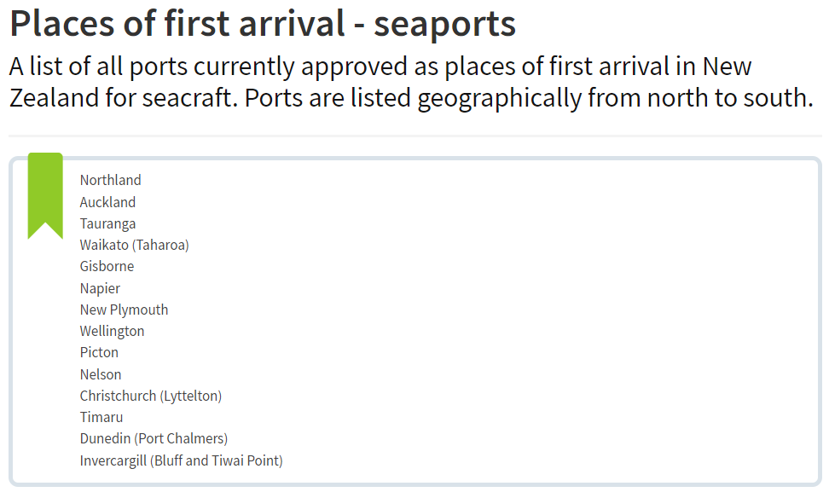

**First Arrival at non-PoFA**

As per NZ's Biosecurity Act 1993, section 37A, ships will need approval for first arrival at locations NOT approved as Places of First Arrival (non-PoFA). This needs to be applied for by Port Operations and may be issued by The Ministry of Primary Industries (MPI) but will require control measures for biofouling (e.g. see below **Acceptable methods for meeting the above CRM Standards)**

**Ships will be required to have a “clean hull” when arriving in New Zealand with differing thresholds for cleanliness (under Craft Risk Management Standards (CRMS) as follows** (see also photos below):

* **“long stay vessels”** are allowed to have only slime layer or gooseneck barnacles on all hull surfaces

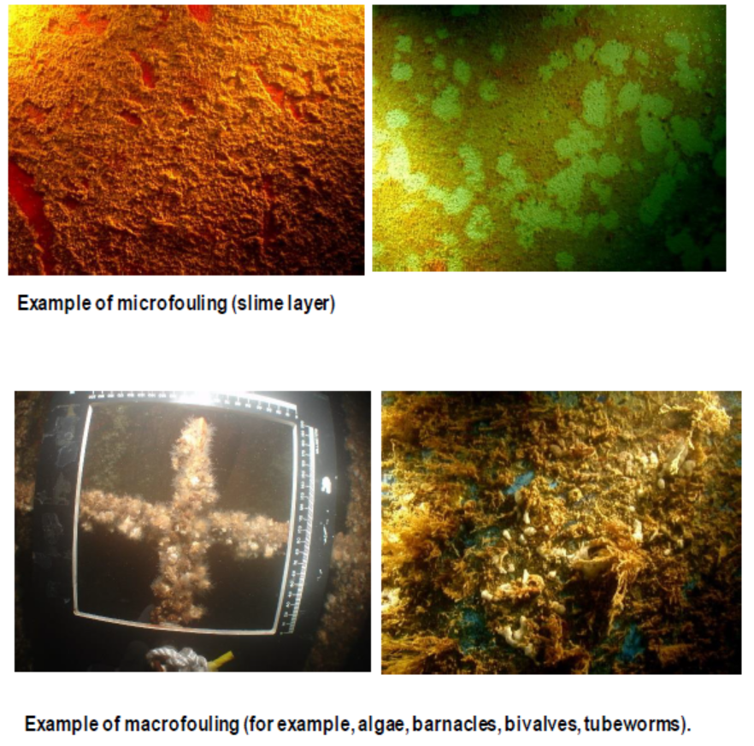

* **“short stay vessels”**, in addition to the slime layer and gooseneck barnacles - can also have slight fouling on the wind and water line of early stage biofoules (e.g. barnacles, tubeworms, bryozomes) < 1% of the hull coverage and <5% of niche areas coverage – see details below:

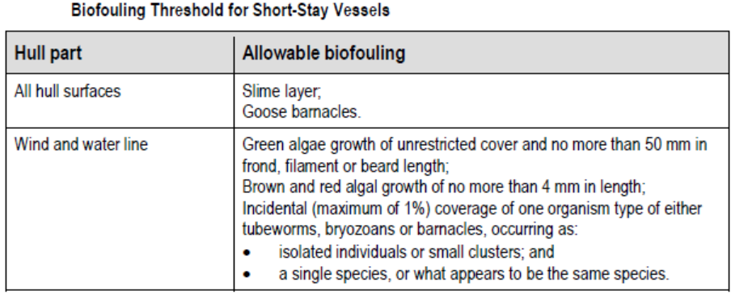

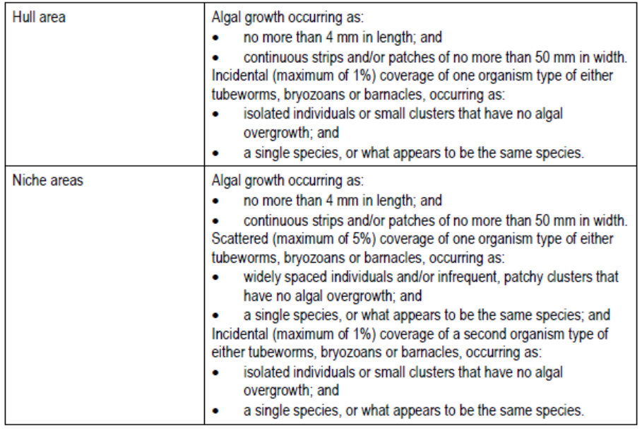

* **the presence of High Risk organisms** like Mussels, Oysters, Sea Anemones or Slime, algae or barnacles growing on top of other fouling organisms indicates ineffective biofouling management and **presents a high possibility that the vessel will be found not in compliance**

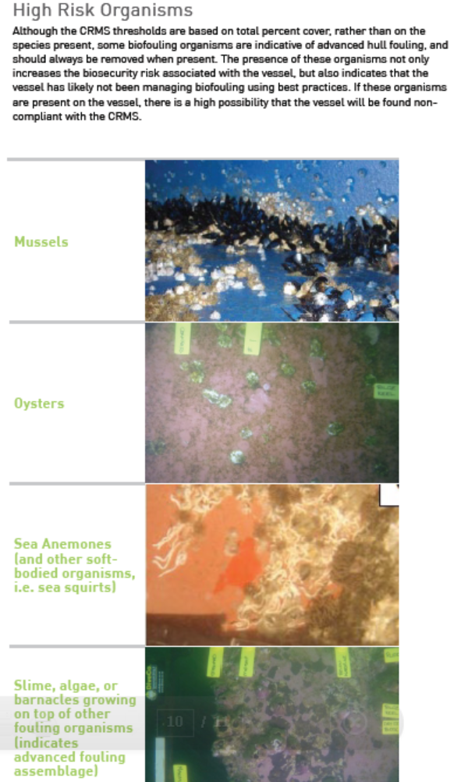

See document “Guidelines for diving service providers inspecting vessels arriving to New Zealand” with more details of what is acceptable or not per the above criteria, at: <https://www.mpi.govt.nz/dmsdocument/27852/send>

**Acceptable methods for meeting the above CRM Standards**

One of the following measures must be applied to meet the ‘Clean Hull’ requirement:

*[recommended for long-stay vessels:]*

* **Cleaning less than 30 days before arrival to New Zealand - all biofouling from all parts of the hull** 
  + The cleaning/service treatment supplier must be locally approved
  + Must provide evidence such as hull cleaning or dry-docking reports which should include photographs /video

*[recommended for short-stay vessels:]*

* **Continual Maintenance using best practice including:**
  + application of appropriate antifoul coatings;
  + operation of marine growth prevention systems (MGPS) on sea-chests; and
  + in-water inspections with biofouling removal as required
    - must provide evidence such as hull cleaning or dry-docking reports which should include photographs /video

Following the IMO Biofouling Guidelines MEPC 207(62) is recognised as an example of best practice

*Application of MPI Approved Treatments*

* **Cleaning within 24 hours after time of arrival in a facility or by a system, approved by NZ’s Ministry for Primary Industries (MPI))- all biofouling must be removed from all parts of the hull** 
  + **Currently haul out/dry docking is the only approved treatment within NZT and is only available for smaller vessels (120m or less)**
  + Must provide evidence such as hull cleaning or dry-docking reports which should include photographs /video
* **Alternative to the Acceptable Measures above**
  + **A vessel operator may submit, for MPI approval, a Craft Risk Management Plan (CRMP) which includes steps that will be taken to reduce risk to the equivalent degree as meeting the requirements of this standard.**
  + **Such CRMP shall be part of this Biofouling Management Plan**

**Before arrival in New Zealand**

(after calling another country (or being in in another country’s territorial waters)):

* Complete and send all documentation to Customs and border agencies at least 48 hours before arrival
  + Complete an application form if intending to arrive at a port other than a place of first arrival approved for your vessel. The application must give well-supported reasons for arriving at the specified place. Apply early because it can take up to 10 days to respond to a request. (Cruise ships should apply well before the start of a season in New Zealand)
* Be familiar and comply also with the standard “Requirements for Vessels Arriving in New Zealand” which relate to and manage specific biosecurity risks, including:
  + pests (incl. Asian Gypsy Moth)
  + garbage
  + food provisions
  + wood packaging and dunnage
  + animals and plants
  + ballast water
  + biofouling (as per these procedures)

Generally:

* Short stay vessels remain under bio-security monitoring while in New Zealand waters
* Long stay vessels must receive a written confirmation from an inspector before leaving the PoFA or otherwise within 20 consecutive days of entering New Zealand territory that are cleared for bio-security and are free to travel anywhere in New Zealand without further biosecurity monitoring

**Cruise ships should also note that:**

* prior approval is needed to arrive at any place, such as Fiordland, that is not one of New Zealand's approved places of first arrival. If approval is given, special conditions will apply.
* MPI inspectors will need to assess and inspect vessels before any passengers disembark.
* before any passengers leave the vessel, a biosecurity announcement must be broadcast in relevant languages

*See more about cruise ships arrivals at:* [*https://www.mpi.govt.nz/importing/border-clearance/vessels/arrival-process-steps/cruise-ships-and-passengers/*](https://www.mpi.govt.nz/importing/border-clearance/vessels/arrival-process-steps/cruise-ships-and-passengers/)

*All the required forms for arrival are available at:* [*https://mpi.govt.nz/news-and-resources/resources/forms-and-templates/*](https://mpi.govt.nz/news-and-resources/resources/forms-and-templates/)

*Check the complete arrival requirements at:* [*https://www.mpi.govt.nz/importing/border-clearance/vessels/arrival-process-steps/*](https://www.mpi.govt.nz/importing/border-clearance/vessels/arrival-process-steps/)

**Specific Information requirements with regards to biofouling** when the vessel is 48 hours out from New Zealand

(1) **Prior to arriving in New Zealand all ships must provide to MPI the following information (via the Advanced Notice of Arrival and associated documents below):**

a) Intended length of stay within New Zealand territory and intentions in respect of places to be visited

b) Whether the vessel has spent any extended periods mainly stationary in a single location

c) If the vessel is coming in to undergo biofouling cleaning on arrival, any formal arrangement for cleaning or treatment and whether they will be undertaken immediately upon arrival (within 24 hours)

d) What measures have been or will be used to meet the requirements of the standard, or

e) Whether the operator has chosen to operate an MPI approved Craft Risk Management Plan (CRMP) as an alternative to meeting the requirements of the standard.

**The above information is to be sent by means of:**

* [Advance Notice of Arrival (Form NZCS 344) – Customs' website](https://www.customs.govt.nz/globalassets/documents/forms/nzcs-344-new-zealand-border-agencies-advance-notice-of-arrival.docx)
* [Master's Declaration for Full Biosecurity Clearance](https://www.mpi.govt.nz/dmsdocument/7233-masters-declaration-for-full-biosecurity-clearance) (for long stay vessels)
* [Biofouling and Ballast Water Declaration parts 1 and 2](https://www.mpi.govt.nz/dmsdocument/11752-biofouling-and-ballast-water-declaration-part-1-and-2)
* [Biofouling and Ballast Water Declaration part 3](https://www.mpi.govt.nz/dmsdocument/11755-biofouling-and-ballast-water-declaration-part-3) (only needed if the vessel will discharge ballast in NZ waters)

**Email completed documentation to the NZ Customs Service (Customs) at** [apicustodian@customs.govt.nz](mailto:apicustodian@customs.govt.nz)

MPI will automatically get documents sent to these Customs' email addresses.

**If you need to contact MPI directly, email**[**vessels@mpi.govt.nz**](mailto:vessels@mpi.govt.nz)

(2) **The following information (if relevant) must be held on the vessel and provided to MPI in an appropriate form if requested. (This is in addition to information to be provided prior to arrival)**.

a) Information on the antifouling regime and any marine growth prevention systems used

b) Whether applying the IMO Biofouling Guidelines, including employing a biofouling management plan showing the hull maintenance and inspection regime and records of biofouling management kept, preferably consistent with the template in the IMO guidelines

c) If applicable to the vessel, its latest International Anti-fouling System Certificate or International Anti-fouling System Declaration

d) Date and reporting from the latest hull biofouling inspection (undertaken either on land or inwater) that was initiated by the vessel operator.

**Upon arrival in New Zealand**

Follow any entry or arrival directions given by MPI

Travel directly to the PoFAthat you noted in the Advance Notice of Arrival form, unless otherwise directed by MPI

Do not carry out any in-water cleaning of your hull in the NZ waters, unless authorised by MPI or using an MPI-approved treatment provider.

The Ministry of Primary Industries (MPI) will perform an assessment on the bioufouling risk profile of the vessel and will advise the level of verification to be conducted

MPI may:

* issue a compliance certificate so that the vessel can continue its journey in NZ or
* require an underwater inspection upon arrival on the account of the vessel to verify the degree of biofouling
  + If the requirements are not met, biosecurity compliance will not be given and the vessel will be directed for further action.
  + Any vessel that can be managed by approved local treatment providers or haul out facilities may be directed for treatment (clean in-water or hauled out for cleaning).
  + Any vessel that cannot be treated by approved treatment providers may be directed out of NZ waters for treatment before being allowed to come back into NZ waters.
  + Any biofouling management or costs due to delays for non-compliant vessels will be at the vessel owner’s or operator’s expense

For further guidance see the FAQ at: <https://www.mpi.govt.nz/dmsdocument/11671/send>

# Annex 2 / Biofouling Record Book – biofouling management actions

Period From: .............................. To: ......................................

Name of Ship: ..............................

IMO number: ..............................

Gross Tonnage: .........................................................................

Flag: ...........................................................................................

## Introduction

Maintain onboard to record the details of all inspections and biofouling management measures undertaken on the ship.

Complete as per the guidance notes in case of docking, UW survey, failure of antifouling systems

**Maintain for the life of the ship. Keep also any older versions or revisions of the Bio-Fouling Record Book.**

**Print and use more than one page per type of record/event required**

## Entries in the Biofouling Record Book

### 2.1 After each Dry-Docking

|  |  |  |  |  |  |  |  |
| --- | --- | --- | --- | --- | --- | --- | --- |
| a. Date From: |  | | To: |  | | Location: |  |
| b. Date Re-floated: | |  | | |

|  |  |  |
| --- | --- | --- |
| **2.1** | **Item** | **Record of management actions** |
| c. | Details of hull cleaning carried out  Areas cleaned  Method used for cleaning  Location of dry-dock support blocks. |  |
| d. | Anti-fouling coating system, including patch repairs, applied.  Type of anti-fouling coating system, the area and locations applied to,  Coating thickness achieved  Surface preparation work undertaken (e.g., complete removal of underlying coating system or application of new anti-fouling coating system over the top of existing coating system). |  |
| e. | Name, position and signature of the person in charge of the activity |  |

Signature of Master:

### 2.2 After each Diving / under water Inspection (of the hull area, fittings, niches and voids below the waterline)

|  |  |  |  |  |  |
| --- | --- | --- | --- | --- | --- |
| a. Date From: |  | To: |  | Location: |  |
| b. Area or side surveyed: |  | | | Reason for Survey: |  |

|  |  |  |
| --- | --- | --- |
| **2.2** | **Item** | **Record of management actions\*\*** |
| c. | General observations with regard to biofouling i.e.  Extent of biofouling and predominant biofouling (%age)  Types, e.g., mussels, barnacles, tubeworms, algae and slime).  If photographs or video taken  Samples taken (if any) |  |
| d. | Action taken, if any, to remove or otherwise treat biofouling. |  |
| e. | Any supporting evidence of the actions taken (e.g., report* from the classification society or contractor, photographs and receipts) |  |
| f. | Name, position and signature of the person in charge of the activity |  |

* Attach copies of reports

**If any of the niche area management practices listed in the Biofouling Management Plan are not conducted as planned, the reason(s) why the practice(s) were not conducted shall be documented California 4.8, 2298.6 , c (2) C

Signature of Master:

### 2.3 After each Underwater Cleaning (of the hull area, fittings, niches and voids below the waterline)

|  |  |  |  |  |  |
| --- | --- | --- | --- | --- | --- |
| a. Date From: |  | To: |  | Location: |  |

|  |  |  |
| --- | --- | --- |
| **2.3** | **Item** | **Record of management actions\*\*** |
| b. | Hull areas, fittings, niches and voids cleaned/treated. |  |
| c. | Methods of cleaning or treatment used.  (e.g. Mechanical brushing, Propeller polishing etc) |  |
| d. | General observations with regards to biofouling remaining  i.e. extent of biofouling and predominant biofouling  types, eg., mussels, barnacles, tubeworms, algae and slime). |  |
| e. | Any supporting evidence of the actions taken (e.g. report* from the classification society or contractor, photographs and receipts). |  |
| f. | Records of permits required to undertaken in-water cleaning if applicable. |  |
| g. | Name, position and signature of the person in charge of the activity |  |

* Attach copies of reports

**If any of the niche area management practices listed in the Biofouling Management Plan are not conducted as planned, the reason(s) why the practice(s) were not conducted shall be documented [California 4.8, 2298.6 , c (2) C]

Signature of Master:

### 2.4 After the Internal Seawater Cooling Systems’ inspection, cleaning or treatment

|  |  |  |  |  |  |
| --- | --- | --- | --- | --- | --- |
| a. Date From: |  | To: |  | Location: |  |

|  |  |  |
| --- | --- | --- |
| **2.4** | **Item** | **Record of management actions** |
| b. | General observations with regard to biofouling of internal seawater cooling system  (i.e. extent of biofouling and predominant biofouling types, e.g., mussels, barnacles, tubeworms, algae, slime). |  |
| c. | Any cleaning or treatment undertaken. |  |
| d. | Methods of cleaning or treatment used. |  |
| e. | Any supporting evidence of actions taken (e.g, report* from the classification society or contractor, photographs and receipts). |  |
| f. | Name, position and signature of the person in charge of the activity |  |

* Attach copies of reports

Signature of Master:

### Ships with a Marine Growth Protection System (MGPS) fitted

* + 1. Records of operation and maintenance (such as regularly monitoring the electrical and mechanical functions of the systems)
    2. Any instances when the system was not operating in accordance with the biofouling management plan

|  |  |  |  |
| --- | --- | --- | --- |
| **Date** | **Item number**  **(e.g. 2.5.a or 2.5.b)** | **Record of management actions\*** | **Name, Rank, Signature of officers in charge** |
|  |  |  |  |
|  |  |  |  |
|  |  |  |  |
|  |  |  |  |
|  |  |  |  |
|  |  |  |  |
|  |  |  |  |
|  |  |  |  |
|  |  |  |  |

*If any of the niche area management practices listed in the Biofouling Management Plan are not conducted as planned, the reason(s) why the practice(s) were not conducted shall be documented [California 4.8, 2298.6 , c (2) C]

Signature of Master:

### Periods of time ship was laid up / inactive for an extended period of time

|  |  |  |  |  |  |  |
| --- | --- | --- | --- | --- | --- | --- |
| a. Date From: |  | | To: |  | Location: |  |
| b. Date Returned Normal Operation: | |  | | |

|  |  |  |
| --- | --- | --- |
| **2.6** | **Item** | **Record of management actions\*** |
| c. | Maintenance action taken prior to and following the period laid up. |  |
| d. | Precautions taken to prevent biofouling accumulation (e.g., sea chests blanked off) |  |
|  | Name, position and signature of the person in charge of the activity |  |

*If any of the niche area management practices listed in the Biofouling Management Plan are not conducted as planned, the reason(s) why the practice(s) were not conducted shall be documented [California 4.8, 2298.6 , c (2) C]

Signature of Master:

### Periods of time when ship operating outside its Normal Operating Profile

1. Duration and dates when ship not operating in accordance with its normal operating profile*
2. Reason for departure from normal operating profile (e.g., unexpected maintenance required)

|  |  |  |  |
| --- | --- | --- | --- |
| **Date** | **Item number**  **(e.g. 2.7.a or 2.7.b)** | **Record of management actions** | **Name, Rank, Signature of officers in charge** |
|  |  |  |  |
|  |  |  |  |
|  |  |  |  |
|  |  |  |  |
|  |  |  |  |
|  |  |  |  |
|  |  |  |  |
|  |  |  |  |
|  |  |  |  |

* For New Zealand - consider periods of 20 days or more

* **For California** – for extended residency (period 45 days or more in any one port) since its most recent out-of-water inspection, in-water treatment or in-water cleaning - **manage niche areas before arrival** in a Californian port and record it ; record any activities including in-water inspection, in-water cleaning, in-water treatment, or out-of-water maintenance, to manage biofouling on the wetted surfaces of the vessel (4.8, 2298.7)

Signature of Master:

### Details of Official Inspection or Review of Biofouling Risk

|  |  |  |  |  |  |
| --- | --- | --- | --- | --- | --- |
| a. Date From: |  | To: |  | Location: |  |

|  |  |  |
| --- | --- | --- |
| **2.8** | **Item** | **Record of management actions** |
| b. | Port State authority conducting the inspection/review and details of procedures followed or protocol adhered to and inspector/s involved |  |
| c. | Result of inspection/review |  |
| d. | Name, position and signature of the person in charge of the activity |  |

Signature of Master:

### Additional Observations and general remarks

1. Periods of time spent (since last cleaning) in locations that may significantly affect biofouling accumulation (e.g., fresh water, high latitude (Arctic and Antarctic) or tropical ports)

|  |  |  |  |
| --- | --- | --- | --- |
| **Date** | **Item number**  **(e.g. 2.9.a)** | **Record of management actions** | **Name, Rank, Signature of officers in charge** |
|  |  |  |  |
|  |  |  |  |
|  |  |  |  |
|  |  |  |  |
|  |  |  |  |
|  |  |  |  |
|  |  |  |  |
|  |  |  |  |
|  |  |  |  |
|  |  |  |  |

Signature of Master: